RENEWING YOUR KCSC MEMBERSHIP - It’s EASY!

Membership Dues: Membership dues are based on the number of Adult Members on the membership and are charged to the Primary Adult member. No dues are charged for Junior members under 21 included on your membership. Annual Membership Dues are:
- $45 for Primary Adult Member + $25 for one Secondary Adult member on the membership
(or dues for a membership with 2 adults is $70)

Take the $5 On Time Discount off total membership dues if you pay in full by June 30.

If want to add or remove someone from your membership, please see page 2.

If there are no changes, please follow the directions below to renew:

RENEW BY CHECK WITHOUT INVOICE:
Remit check or money order to: Kansas City Ski Club 4741 Central, Suite 343 Kansas City, MO. 64112
Renewals are processed online by a Club administrator after receipt of payment. Members who wish to include an invoice with their payment should follow the “Renew Online” instructions.

RENEW ONLINE:
- Click on the “Member Login” link on the upper right portion of the Home page of the KCSC website:
kcskiclub.org . The member login page appears:

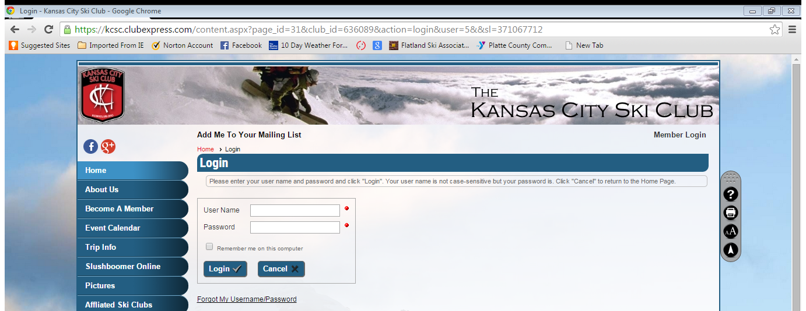

- Enter your User Name aka “login” and your password. If you do not know your User Name or Password, click on “Forgot My Username/Password”. An email will be sent to you with your login and temporary Password. If your email address has changed, please send an email requesting your email address be updated and your password reset to: membership@kcskiclub.org
- After logging in, your name appears on the upper right portion of the Home page. Click on the red circled arrows to the left of your name to renew your membership.
- Follow the prompts to complete the renewal process, updating your contact information, selecting any volunteer activities of interest, and verifying information for the secondary and junior members on your membership.
- To print an invoice and pay by check, select “Print Invoice and Send Check” from the drop down beneath Select Payment Method on the Make Payment for page, then click “Print Invoice and Send Check”
- To remit payment with a credit card, select “Credit Card Processed on This Site” from the drop down beneath Select Payment Method, complete the credit card information and click "Submit Payment"
RENEWING YOUR KCSC MEMBERSHIP – Page 2

ADDING OR REMOVING SOMEONE FROM YOUR MEMBERSHIP:

- You, the Primary Member, want to add member(s) currently on another membership (Examples: you want to add your significant other or your 24 year old son that are currently on separate memberships):
  - DO NOT START THE RENEWAL PROCESS ONLINE YET!!! DO NOT ADD THEM YOURSELF TO YOUR MEMBERSHIP. This will only create duplicate membership records for them and they will still get renewal emails for their existing membership, etc.
  - Confirm with these other members that they are okay with you adding them to your membership.
  - Send an email to membership@kcskiclub.org requesting that the additional members be added to your membership, copy the additional members on your email. Please be sure to include your name and the names of the additional members.
  - Once you hear back that they have been added to your membership, log in to the website and renew.

- You, the Primary Member, want to remove members currently on your membership (Example: you have decided your 21 year old needs to be financially responsible, etc – they need their own membership!!!):
  - DO NOT START THE RENEWAL PROCESS ONLINE YET!!! DO NOT REMOVE THEM YOURSELF FROM YOUR MEMBERSHIP. This will drop them from the KCSC membership list.
  - Send an email to membership@kcskiclub.org requesting they be removed from your membership, copy these folks on your email. Please be sure to include your name and the names of the members to be removed.
  - Once you hear back that they have been set up with their own membership and removed from your membership, log in to the website and renew.

- You, the Primary Member want to add NEW members to your membership:
  - Go to the website, log in and start the renewal process.
  - At Membership Renewal…STEP 5 of 7 screen, add the new members to your membership. Click the "Add" to the right of Secondary Members to add an adult, click the "Add" to the right of "Junior Members to add a junior member.

